The main priority of the first meeting was to draft a design of the exhibit and get a better idea of the overall layout of the pieces and technology. 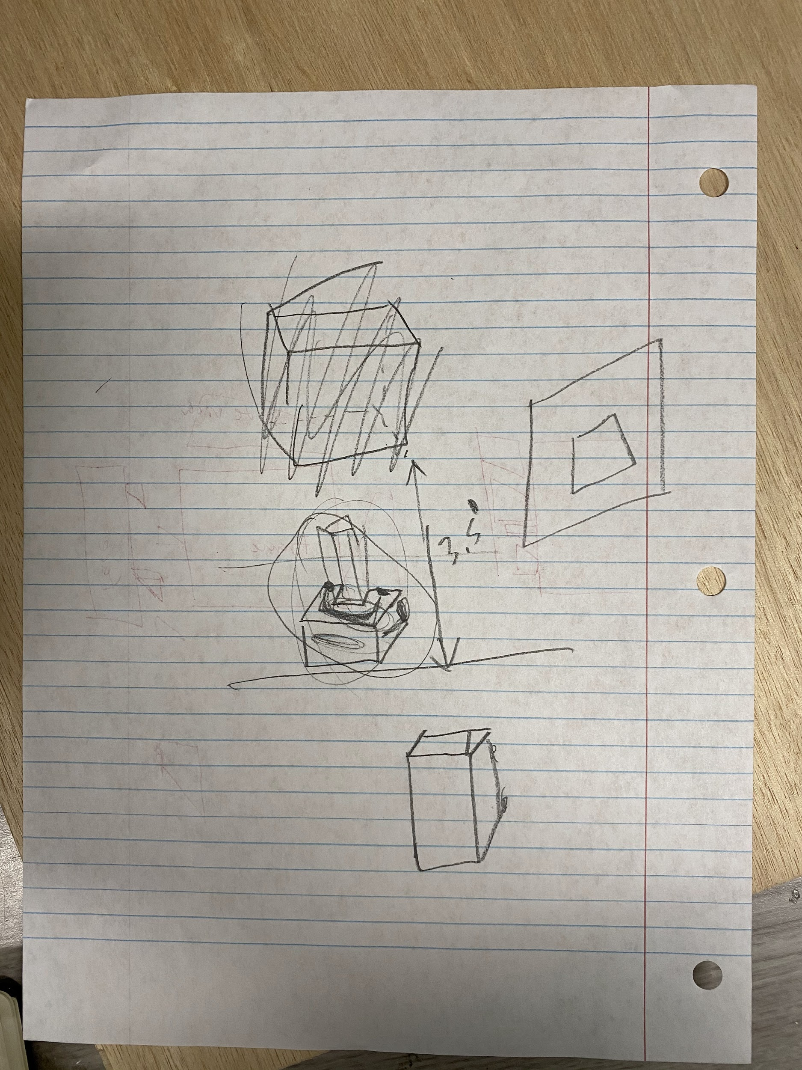

The design on the left is a very rough idea of what we are looking to do with our cardboard design and later on, the full design.

The top box that looks somewhat crossed out is the actual four face that people will be interacting with.

It is then connected to a sort of chimney that will allow cords to pass through from the top box to the “base” of our exhibit, which will contain a lot of the cords, main microcontroller, and power.

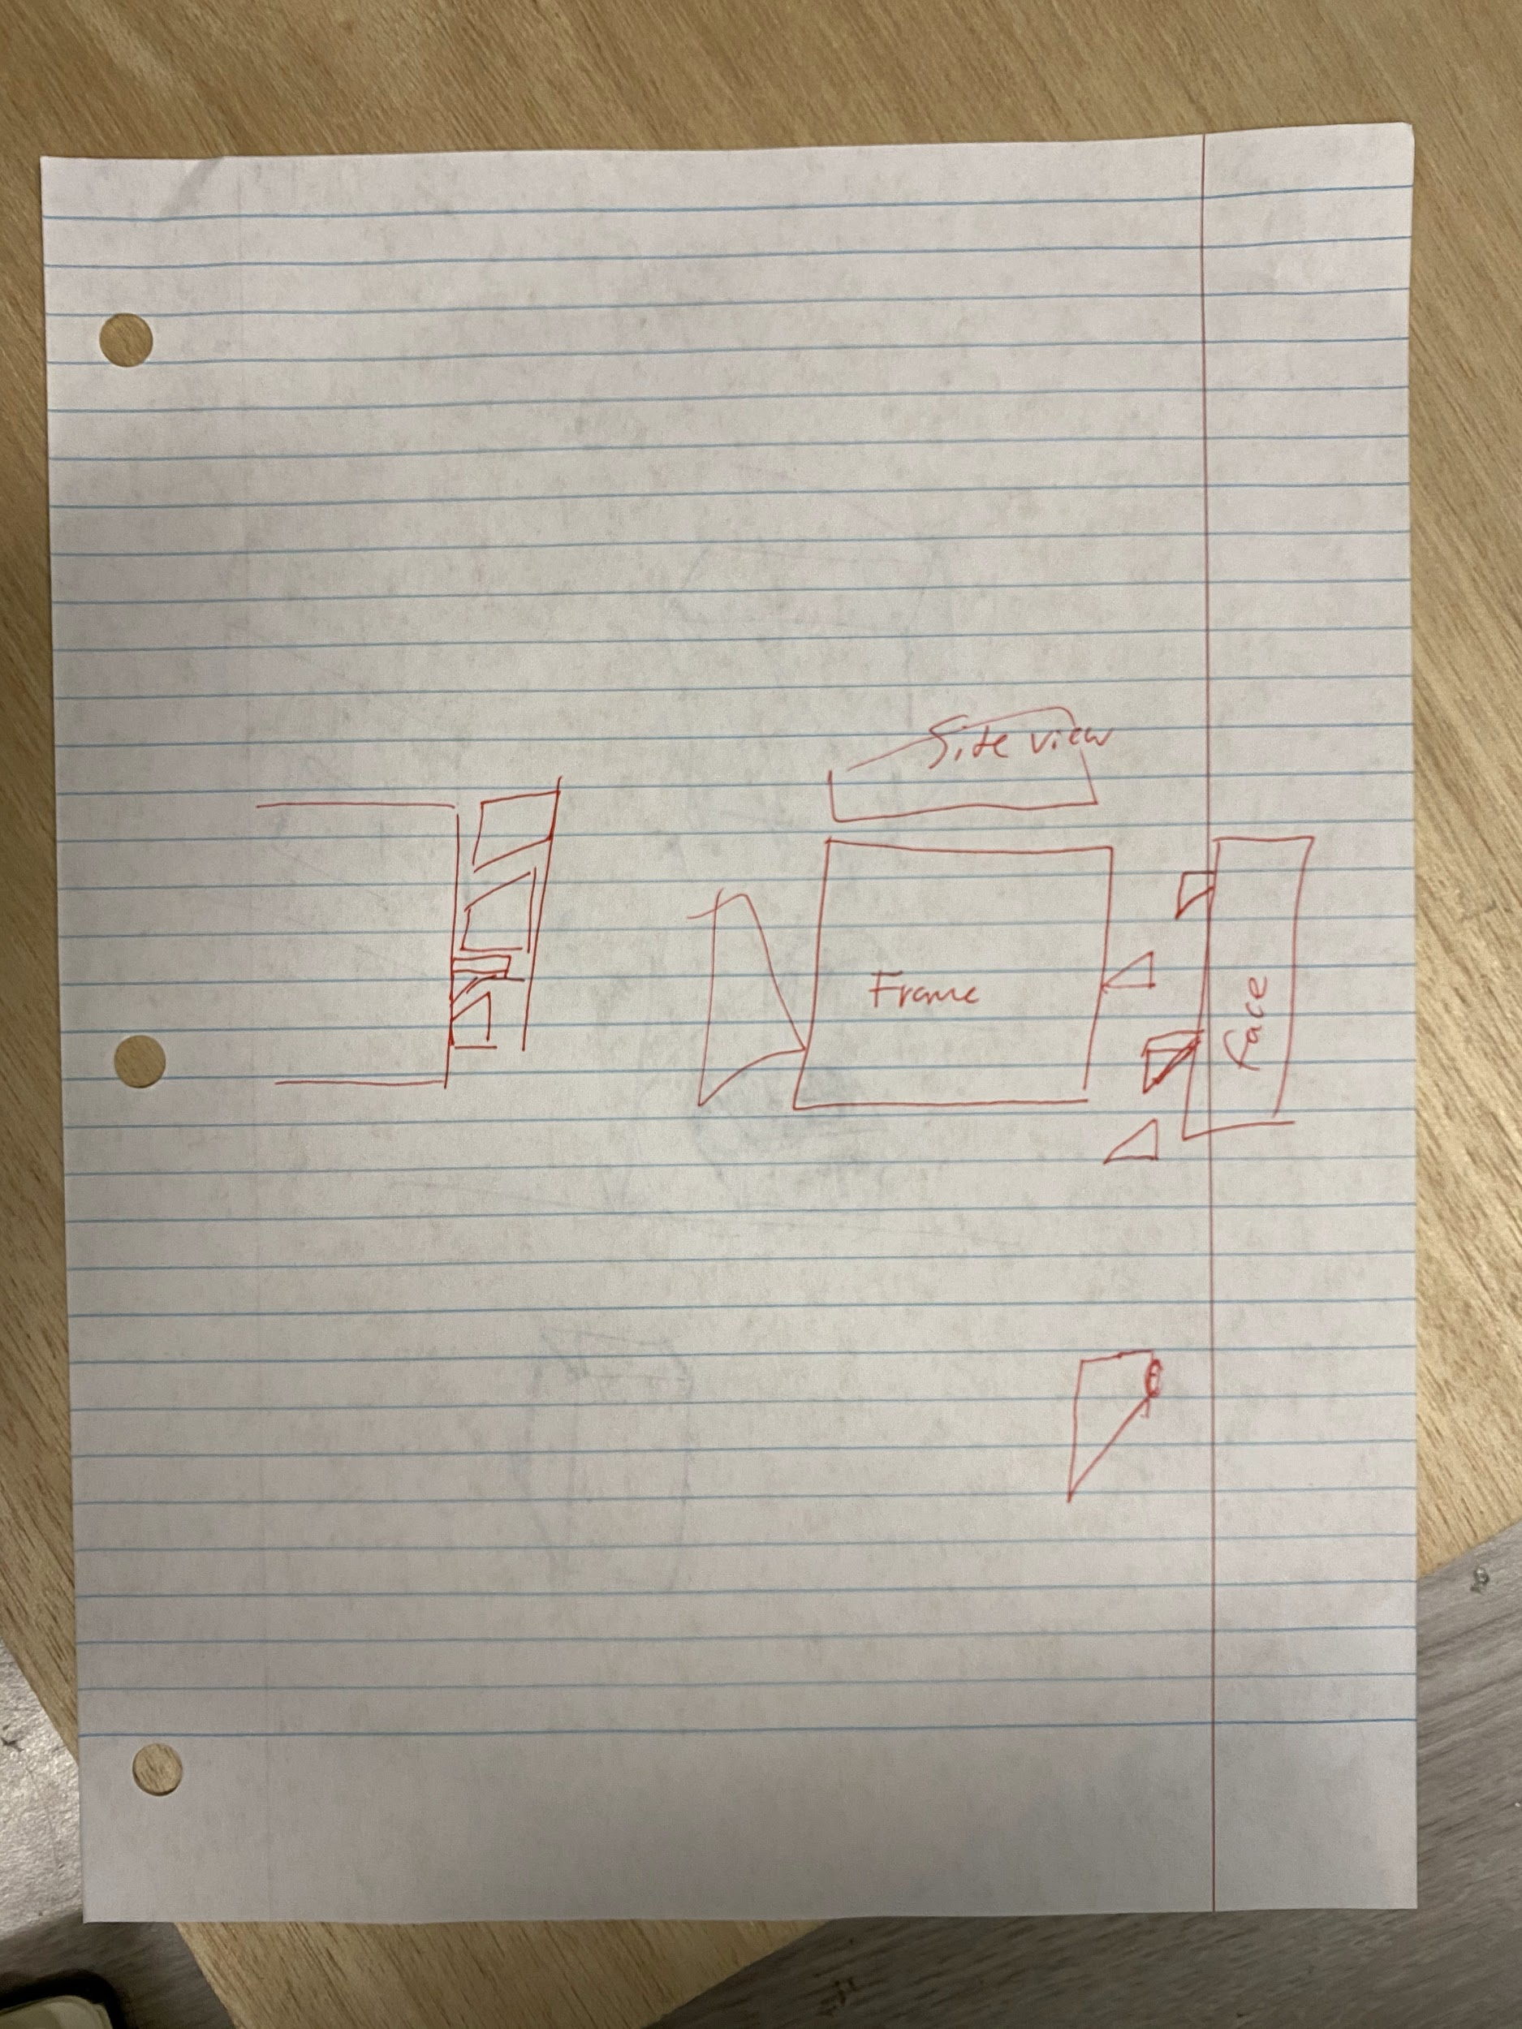

This design (on the right side of the paper) is a SIDE VIEW of the frame and face for the four face part of the exhibit. Here we define the frame to be a sort of holding placement that has no real electronics attached to it. The face is what will contain the capacitive touch, acrylic, and LEDs.

The triangles here are what allow the face and the frame to hook onto one another.

The reason we are making this somewhat more complicated and into seperate components is that it allows us to easily debug the project when things go wrong. The idea behind our mechanical design is the more things that are easily able to be separated, the easier it is for us to access all the parts, dissassemble and reassemble for traveling.

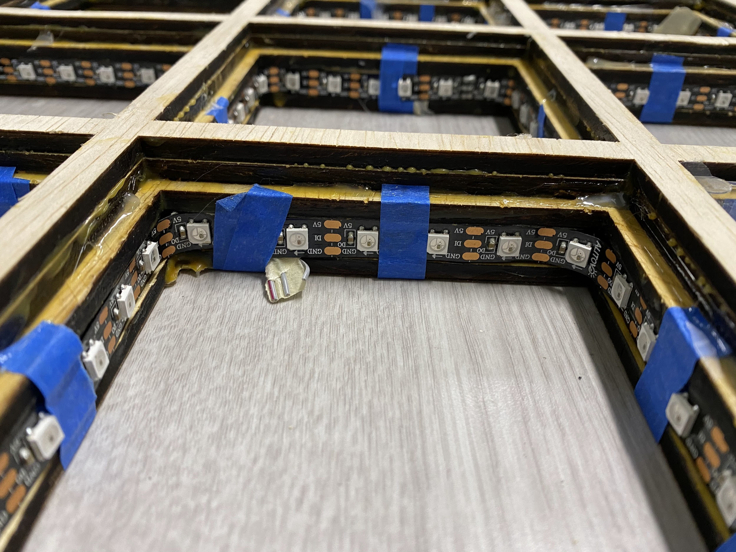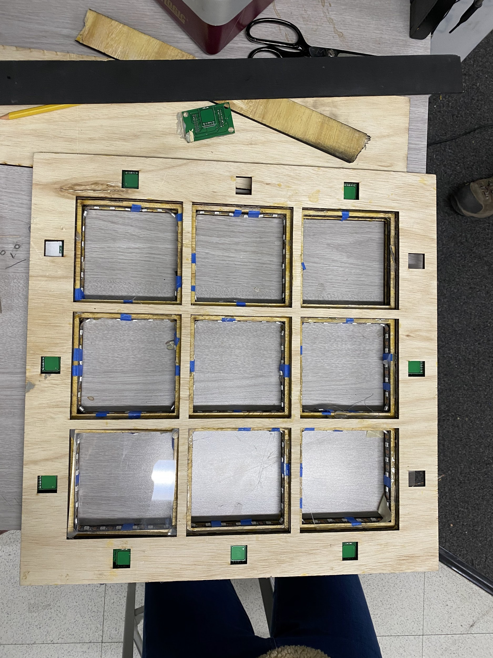

This is an example and prototype from last year’s face. We will be using very similar dimensions as we want it big enough to fill up the player’s view when sitting down/standing up.

In our prototype we will likely be cutting off the large borders that this one has as we will not need the 12 buttons that they have.

We will be doing a similar idea in that we will be layering the face so that it allows us to accomodate for different sizes and shapes when we cut the wood. 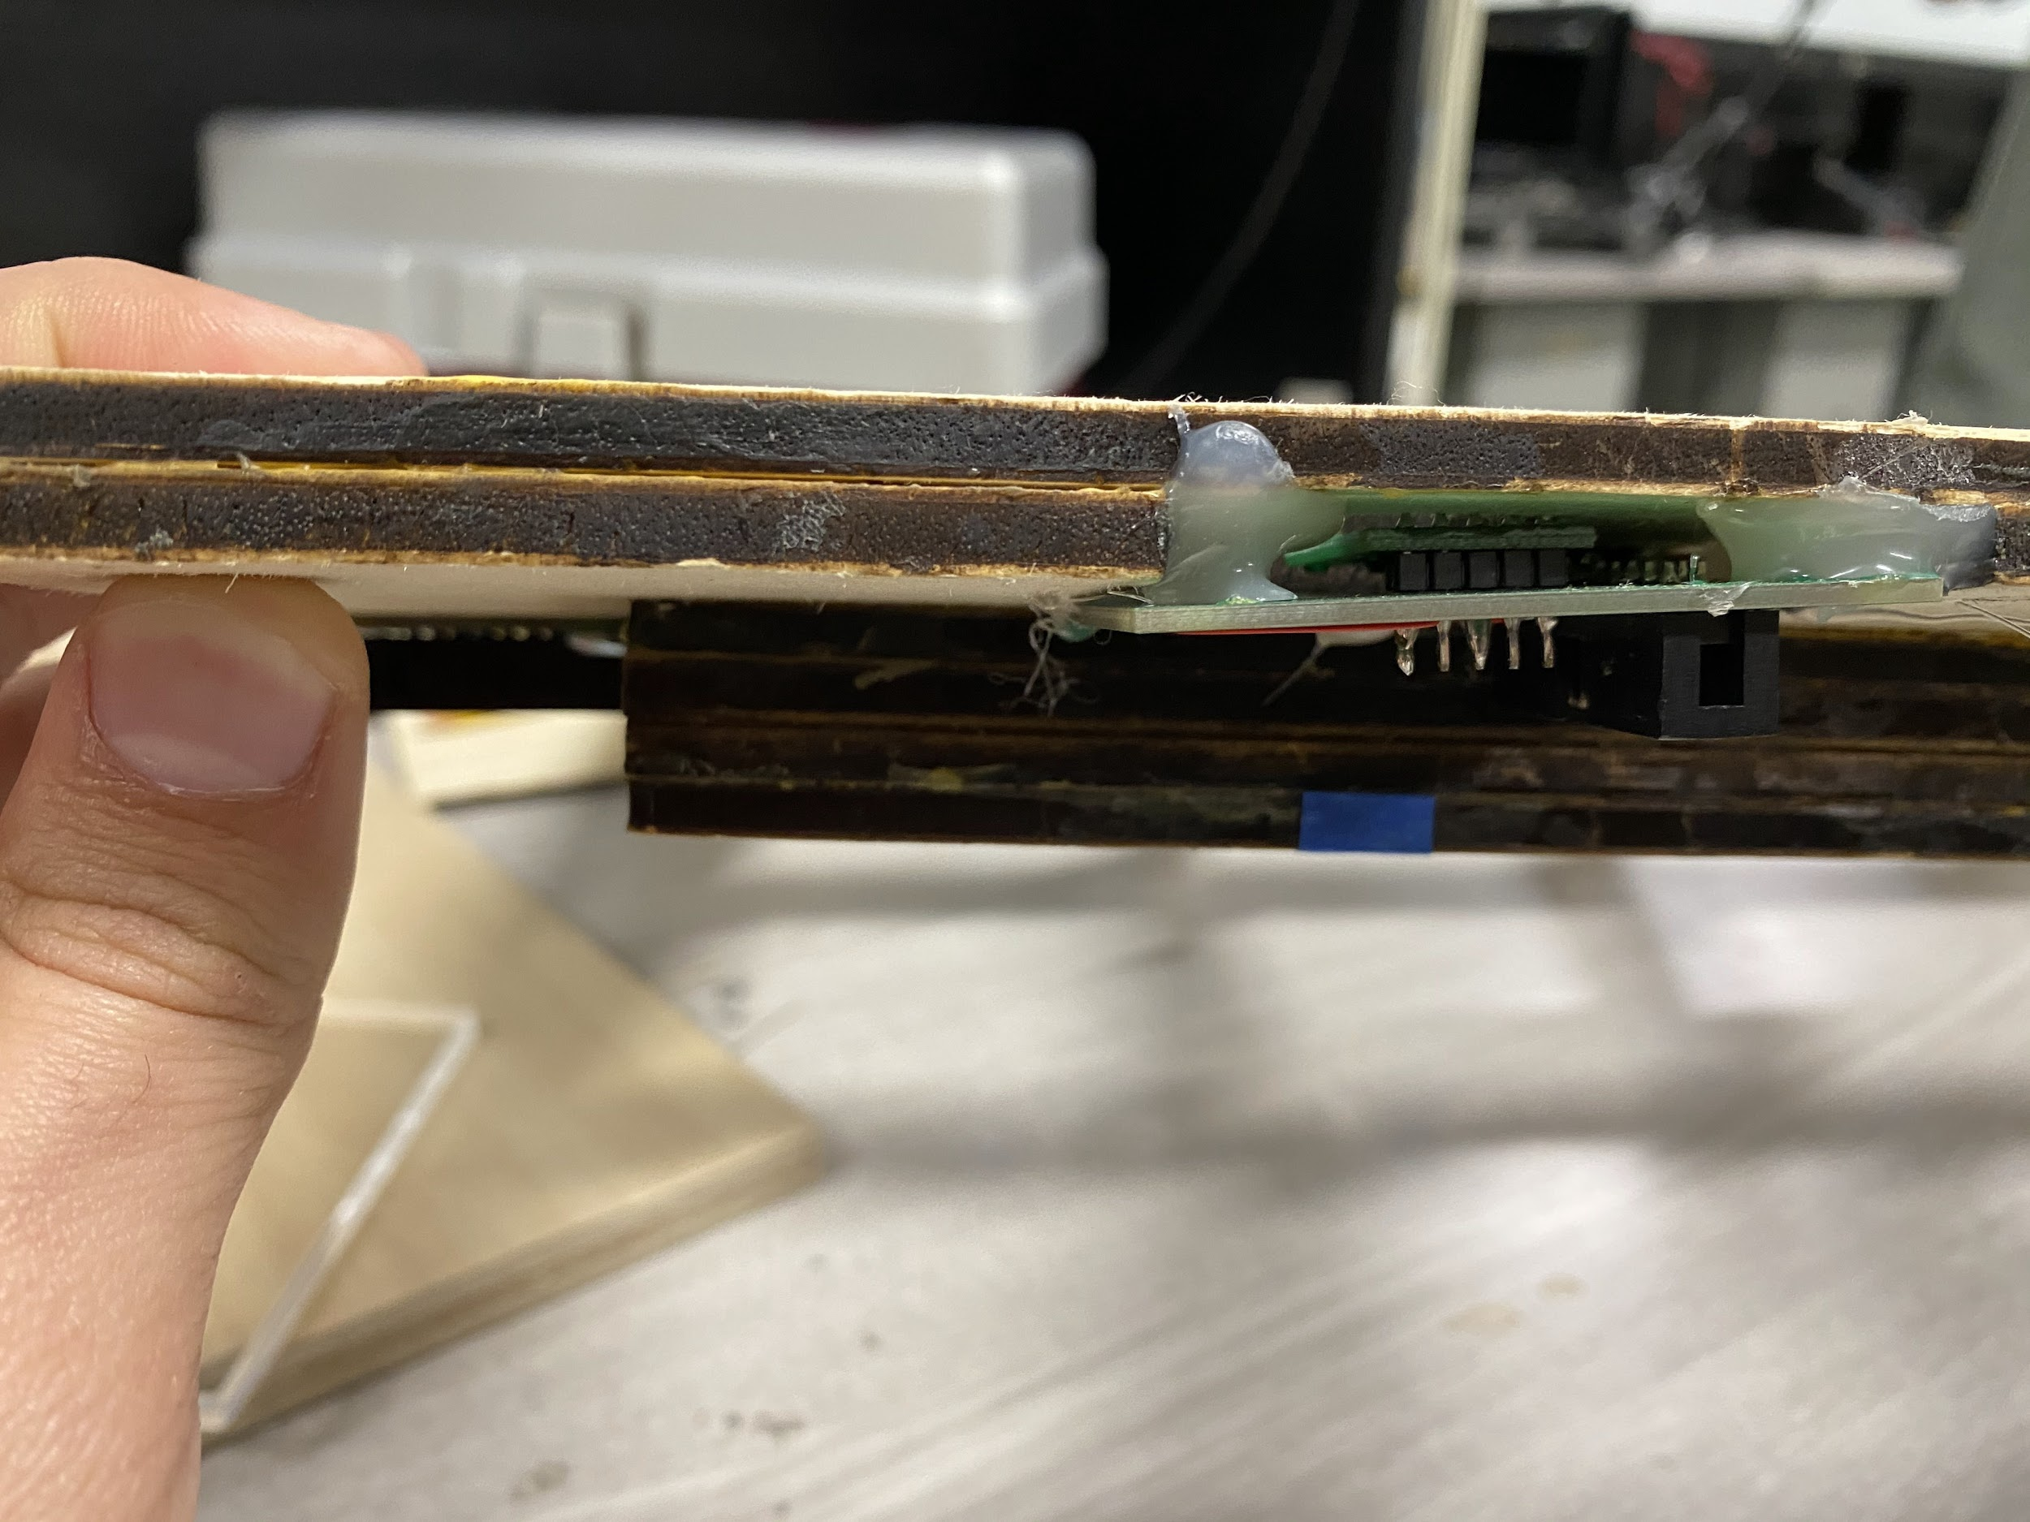

In 3D printing, we generally print it all together as one piece. Because this is a larger project, we are using wooden boards with varying thicknesses and layering them. We still design the boards in CAD because it helps us visualize it and we can transfer it over to a software that will give us an idea of how to cut the wood

**For the sake of the next image, let’s refer to those 6 layers as 1-6 from bottom to top.**

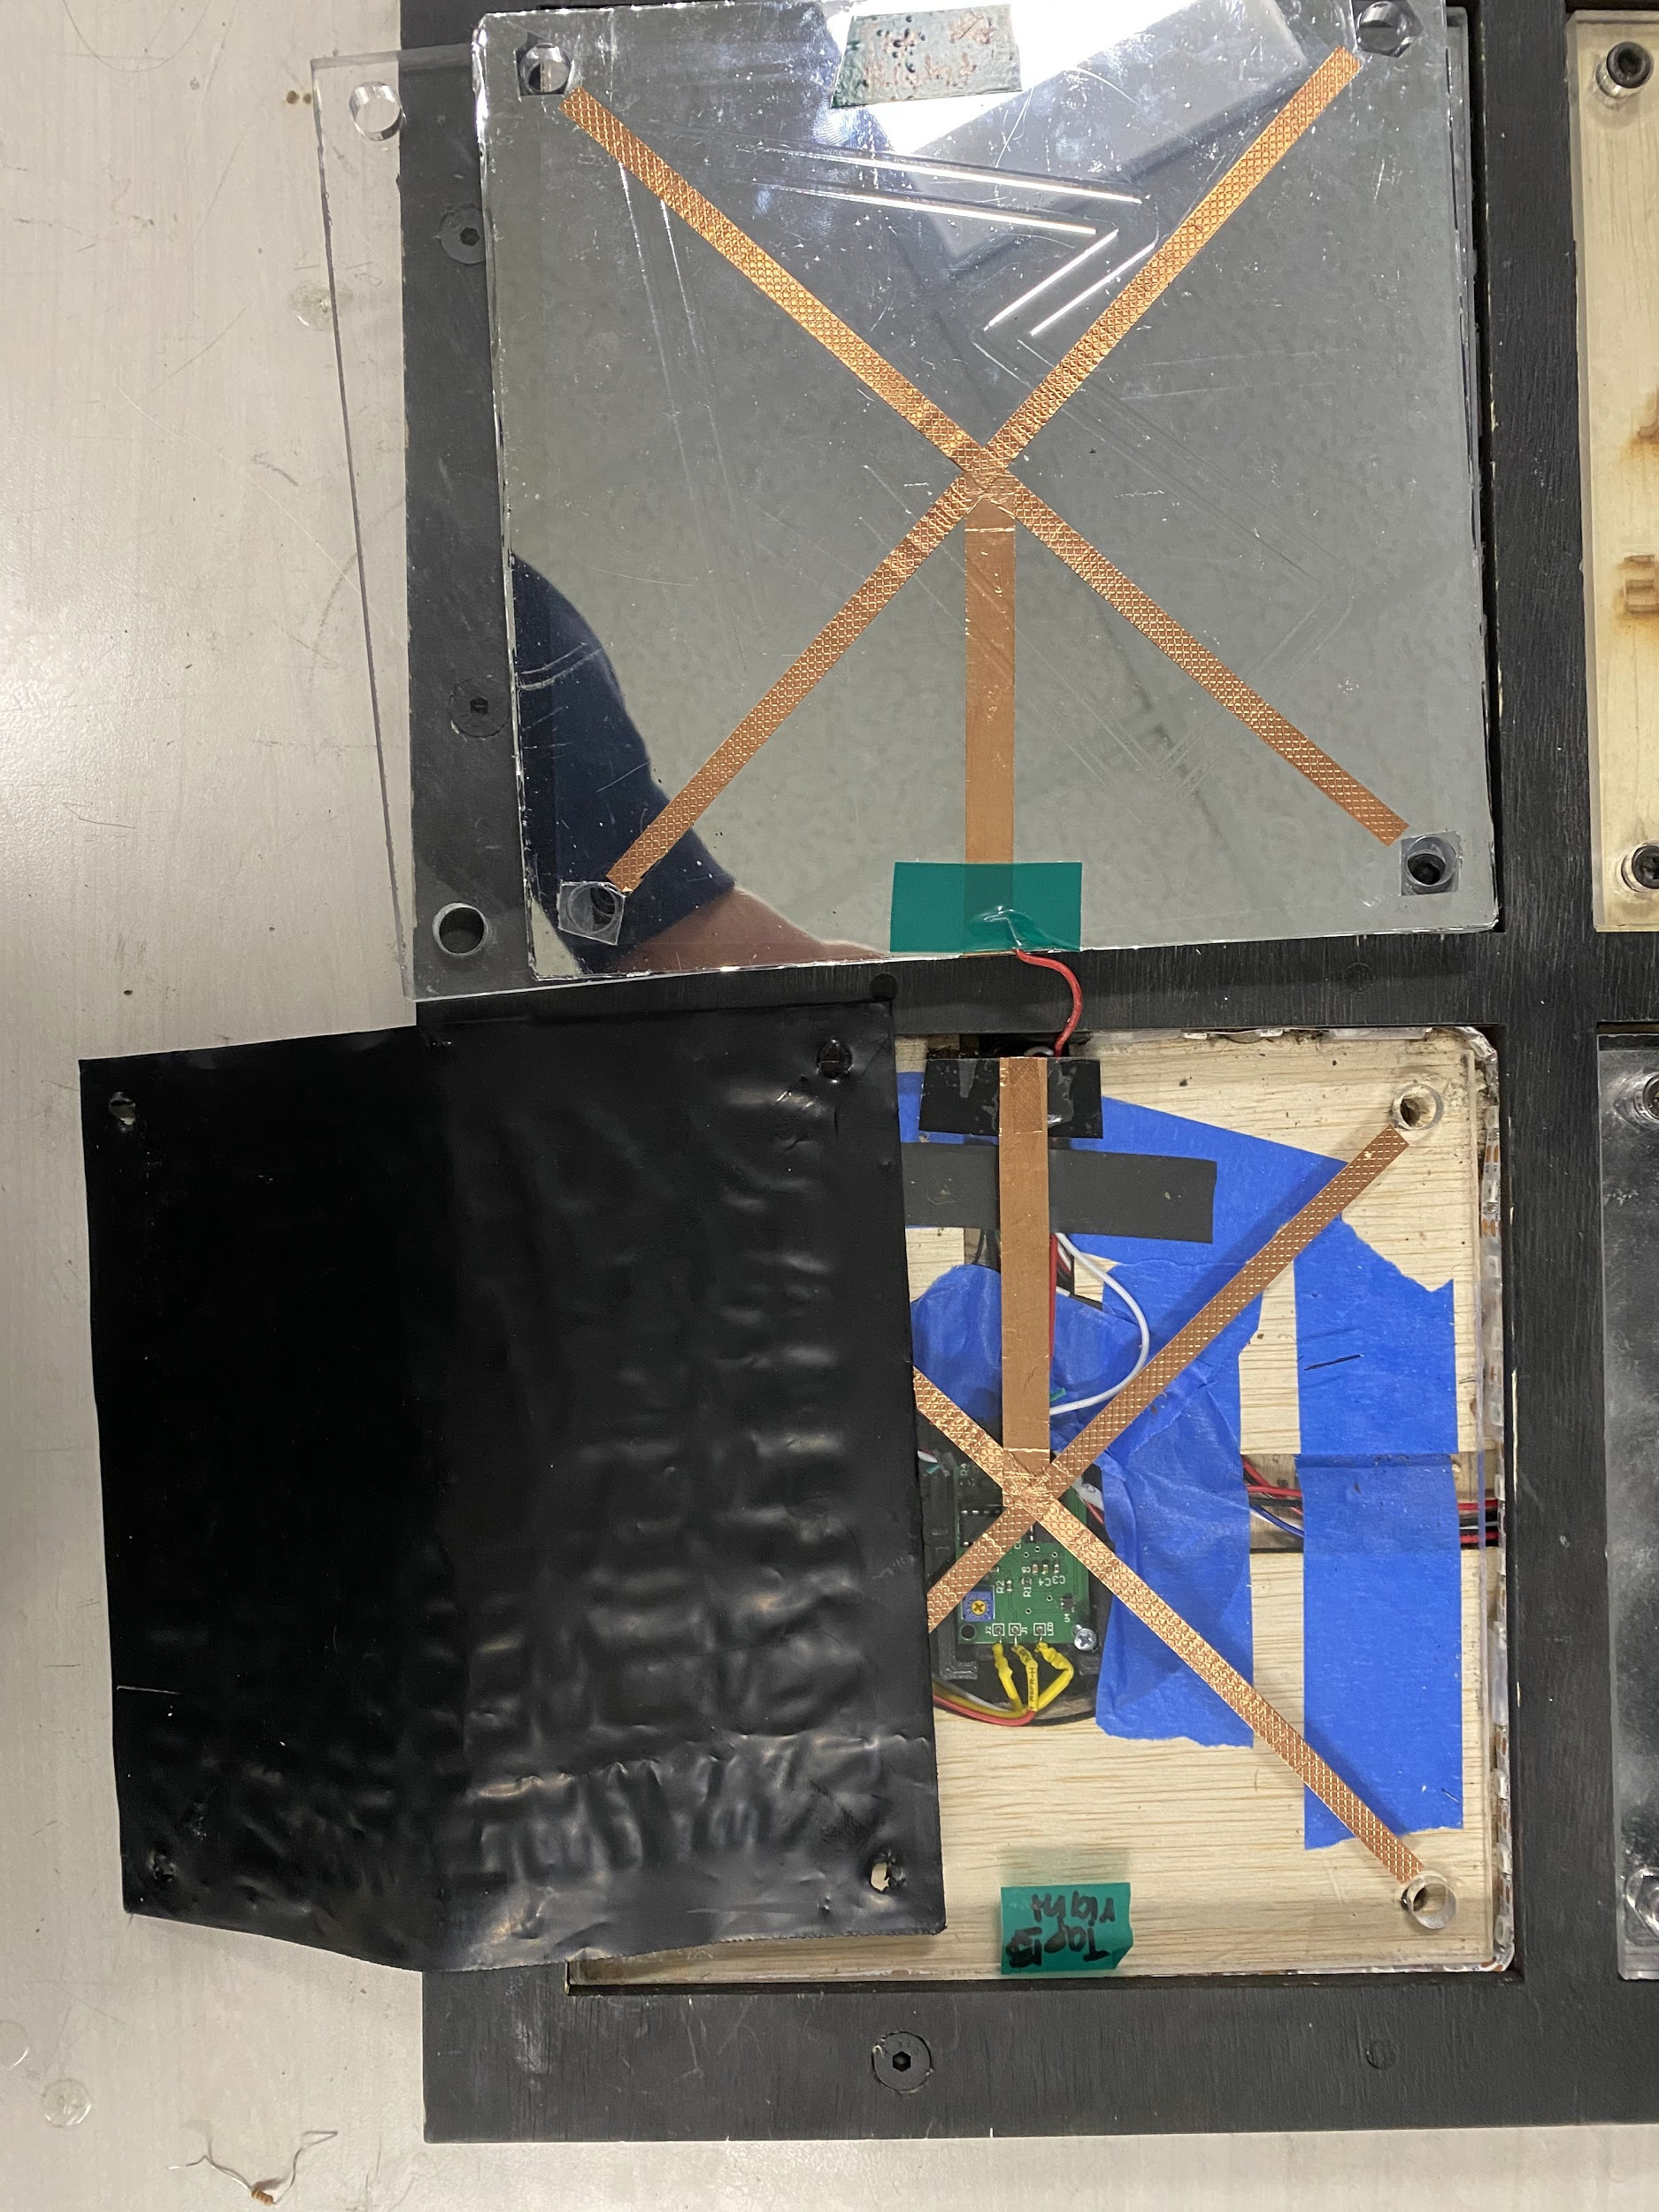

Here is the inside of one of the frames. The layers 2-3 hold the LED strip while layer 1 and layer 4 extend further into the frame to hold the LED strip and acrylic on top. The reason we do that is it allows the LED strip to lay flush with the design and extend only as far as layers 1 & 2 into the frame.

In our design we will most likely consolidate layers 2 and 3 into one layer as they are exactly the same and stacked on top of one another.

At the T-intersections at the corner of the LED strips, we will have tunnels that will allow for wires to pass through.

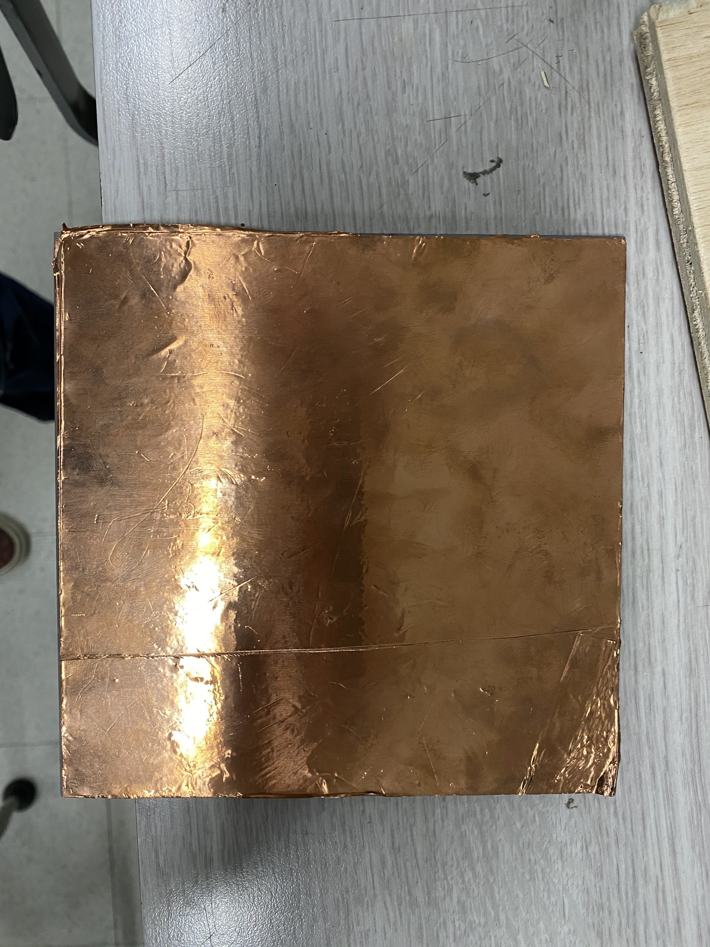

This is some of the wrapping we will be using to design our capacitive touch sensors.

If you are interested in how the capactive touch sensor work, [here is a brief article that explains it](https://www.allaboutcircuits.com/technical-articles/introduction-to-capacitive-touch-sensing/). Essentially, when people’s fingers get within a certain proximity of the acrylic/copper tape, microcontrollers will register a change in capacitance and know that a human finger is touching the button.



Here is the Dance touch pad resistive sensor. You can see the copper tape is connected to a red wire that then connects to a microcontroller to register the signal.

Two types of PCBs:

* One for each face to control capacitive touch sensing
* One PCB to control all with CAT5 connection (So in ALL, 5 microcontrollers)
* After the cardboard prototype, will design PCBs

Capacitive Touch Sensing

* Copper tape around edges and solder wires on to it to connect to pin of MSP430
* Put on acrylic - do 36 of them
* Works by sensing the number of cycles of charging and discharging in a time period to indicate touch
  + Like more cycles if capacitive touch senses touch relative to no touch occurring

**TO DO (TENTATIVE PLAN):**

1. Finish the mechanical design in CAD by week two
2. Cut out the wood for the design by week three
3. Graphics to include: TI, EE emerge, College of Engineering logo, Group Name,